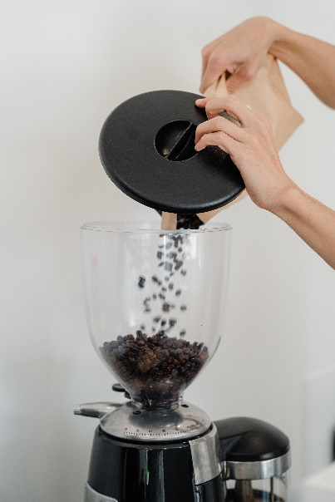Coffee Bean Machine

This is our coffee bean machine, where you are able to put in your selection of coffee beans and freshly grind them to get the best coffee taste you can get. With this machine all you have to do is lift the lid, put in the coffee beans and select the grind size (ranging from a coarse to extra fine grind), and then click the button and watch the machine turn the coffee beans into coffee grounds. We have this machine available in the colours black (with a bit of silver) and the dimensions are 22 x 12.5 x 39 cm. It is easy to set up, use and clean, so buy one today and freshly grind your coffee whenever.

£50.00

Stainless Steel Coffee Machine

With our new stainless steel coffee machine you can pull the best coffee shot, to get it silky smooth and keep the strong flavour of the coffee. All you have to do is put the coffee grounds into the portafilter basket, tap the basket against a hard surface to get it level, tamp the coffee grounds to get the best coffee shot pull, lock it into the group head and then pull the shot. It is quick, simple and easy to do and it guarantees a beautiful coffee shot. All the instructions and equipment will be included, and we have this machine available in silver. The dimensions are 30 x 34 x 40 cm.

£80.00

Black Coffee Machine

Like our Stainless Steel Coffee Machine, we have another one in black and it is slightly smaller in size as well. It has the same usage and the sizing of the portafilter basket is smaller, meaning you can pull a slightly smaller coffee shot. It is easy to dismantle, clean and then set back up again meaning that you can enjoy great coffee tasting all the time with ease. The dimensions are 25 x 30 x 36 cm, and all instructions and equipment are included.

£70.00

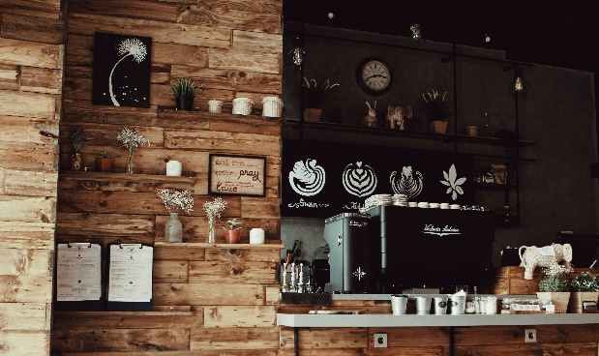Deluxe Coffee Grinder and Machine

Here we have our all-in-one deluxe coffee grinder and machine. With this new machine that we have available you are able to freshly grind the coffee beans and pull the coffee shot at the same time. You can save time and money by buying this all-in-one machine as you can purchase this with our coffee beans to make your own delicious tasting coffee. So, why not save time and money and become your own barista with out new deluxe coffee grinder and machine. All the instructions and equipment will be provided, and the dimensions are 40 x 45 x 42 cm.

£100.00

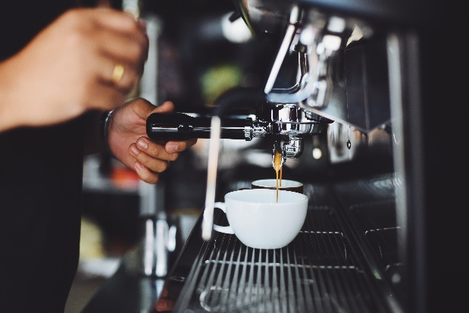Customisable Coffee Machine

With our new customisable coffee machine, you are able to control how you make your perfect coffee. With the new technology, you are able to control the temperature of the coffee and how well tamped you want the coffee grounds to be. We know that coffee lovers are different and your perfect coffee may be different to another person, so with this machine you are able to control how you make you coffee to ensure that it suits you. It works the same as our stainless steel coffee machine, however, with different buttons you can customise the coffee shot that you pull to ensure that it is how you like it. It is 30 x 34 x 40 cm.

£95.00